

JAVA PROJECT REPORT ON
Online Quiz Examination System

Submitted by
SAJITH S
25BIT051

Under the Guidance of
DHILEEBAN A
Technical Trainer
Technical Department, KG College of Arts and Science

Academic Year: 2025 – 2026
APRIL 2026 Semester: I

DECLARATION
I hereby declare that the project entitled “Online Quiz Examination System ” submitted in partial fulfillment of the requirements for the course JAVA PROGRAMMING is a record of my original work carried out under the guidance of , Technical Trainer, Technical Department, KG College of Arts and Science.
I further declare that this project has not been submitted previously, either in part or in full, for the award of any degree, diploma, or other similar title, at this or any other institution.
I have acknowledged all sources of information used in this project wherever applicable.

April 2026
Coimbatore

SAJITH S
(Your Name)

CERTIFICATE
This is to certify that the project entitled “Online Quiz Examination System ” is a bona fide work carried out by [ SAJITH S] [I-BSc IT-.’A’], [], KG College of Arts & Science, in partial fulfillment of the requirements for the course [JAVA PROGRAMMING].
This project has been completed under my supervision and guidance during the academic period April 2026.

Place: COIMBATORE
Date: 09.04.2026

Submitted for the Viva-Voce Examination held on KG COLLAGE OF ARTS & SCIENCE

Guide: Head of the Department
(Technical Trainer, KGCAS) (Technical Head, KGCAS)

______________________ _______________________

TABLE OF CONTENTS
S. No. | Topics | Page. No.
1 | Introduction
1.1 | Objective
1.2 | Overview
1.3 | Features
2 | Program Analysis
2.1 | Problem Definition
2.2 | Project Overview
2.3 | Scopes and Limitations
3 | System Design
3.1 | Modules
4 | Methodology
4.1 | Problem Analysis
4.2 | System Design
4.3 | Program Development
4.4 | Testing and Validation
4.5 | Result and Documentation
4.6 | Algorithm
4.7 | Flowchart
5 | Source Code
6 | Input and Output Screens
7 | Discussion and Conclusion
7.1 | Discussion
7.2 | Conclusion
8 | References

ABSTRACT
The Document & Digital Record Management System (DDRMS) is a Java-based application developed to efficiently manage and organize digital documents. In many organizations, records are often handled manually or stored in unstructured formats, leading to difficulties in searching, data duplication, loss of information, and inefficient record management.
This project aims to simplify document handling by providing an automated system that allows users to store, retrieve, update, and delete digital records easily. The system enables users to manage documents through a menu-driven interface, ensuring quick access and better organization of data.
The application is developed using Core Java programming concepts such as classes, objects, methods, loops, conditional statements, and file handling. It can be implemented as a console-based application or enhanced with a graphical user interface using Java Swing.
The main objective of the system is to improve efficiency, reduce manual effort, and ensure secure and structured storage of documents. The system provides features such as document entry, search functionality, record updating, and deletion, making it suitable for small organizations, offices, and educational institutions.
This project demonstrates the practical implementation of object-oriented programming in Java and provides a foundation for developing advanced document management systems with features like database integration, cloud storage, and enhanced security in the future.

- INTRODUCTION
The Online Quiz Examination System is a console-based application developed using Java. It is designed to conduct quizzes in a digital format and automatically evaluate user responses. This system replaces traditional paper-based examinations, making the process faster, more efficient, and error-free.
The application allows users to log in, attempt multiple-choice questions, and receive instant feedback along with their final score and percentage. It demonstrates the use of object-oriented programming concepts such as classes, objects, arrays, and control structures.

1.1 Objective
The main objective of this project is to design and develop a simple and efficient system that can:
- Conduct online quizzes
- Evaluate answers automatically
- Display results instantly
- Reduce manual effort in correction
It also aims to help students understand Java programming concepts through practical implementation.

1.2 Overview
The system consists of a login module followed by a quiz module. Once authenticated, the user is presented with a series of multiple-choice questions. The user selects answers, and the system checks correctness in real time.
At the end of the quiz, the system calculates:
- Total marks
- Percentage
- Pass/Fail status
This provides a complete evaluation system in a single execution.

1.3 Features
- Simple login authentication
- Multiple-choice questions
- Instant answer validation
- Automatic result calculation
- Percentage and pass/fail display
- User-friendly console interface

- PROGRAM ANALYSIS
Program analysis involves understanding the requirements and determining how the system should function.

2.1 Problem Definition
Traditional examination systems require manual checking, which is time-consuming and prone to errors. There is a need for a system that:
- Conducts exams digitally
- Evaluates answers instantly
- Reduces human effort
The problem is to design a system that can automate this process efficiently using Java.

2.2 Project Overview
The project is a console-based Java application that simulates an online quiz system. It uses:
- Arrays to store questions
- Classes to represent question objects
- Loops to iterate through questions
- Conditional statements for evaluation
The system is simple but demonstrates core programming concepts effectively.

2.3 Scopes and Limitations

Scope:
- Can be used for small quizzes
- Suitable for learning purposes
- Easy to expand with new features

Limitations:
- No database integration
- No graphical interface
- Fixed set of questions
- No timer functionality

- SYSTEM DESIGN
System design is the stage where the structure and components of the system are planned before the actual implementation. In this phase, the system is divided into different modules, and the workflow of the application is defined. Proper system design helps in organizing the program efficiently and makes development easier.
The Online Quiz Examination System is designed as a menu-driven application where users can select food items, enter quantities, and generate a final bill automatically.
The system is divided into several modules to perform specific tasks. Each module is responsible for handling a particular function of the system.
System design defines the structure and working of the system

System design defines the structure and components of the system.

3.1 Modules

The system is divided into the following modules:

Login Module

Accepts username and password

Validates user

Question Module

Stores questions and options

Displays questions

Answer Evaluation Module

Checks user input

Compares with correct answer

Result Module

Calculates score

Displays percentage and result

- METHODOLOGY
Methodology describes the process followed to develop the project. It explains the steps taken from understanding the problem to designing, implementing, testing, and documenting the system.
For the Online Quiz Examination System, a structured development approach was followed to ensure that the system meets the requirements and functions efficiently.
The development process includes the following stages:
• Problem Analysis
• System Design
• Program Development
• Testing and Validation
• Result and Documentation
The DDRMS follows a structured development approach.

This section explains how the system is developed step-by-step.

4.1 Problem Analysis
The problem was analyzed by identifying:
- Input requirements (user answers)
- Processing (evaluation logic)
- Output (score and result)

4.2 System Design
The system was designed using:
- Class structure for questions
- Array for storing quiz data
- Loop for iteration
- Conditions for validation

4.3 Program Development
The program was developed using Java:
- Created a Question class
- Implemented main logic in OnlineQuizSystem
- Used Scanner for input

4.4 Testing and Validation
The system was tested with:
- Correct inputs
- Wrong inputs
- Empty inputs
Validation ensured:
- No crashes
- Correct evaluation
- Proper output display

4.5 Result and Documentation
The results are displayed immediately after quiz completion. Documentation includes:
- Code explanation
- System design
- Output samples

4.6 Algorithm
- Start
- Input username and password
- If valid → continue, else exit
- Load questions
- For each question:
  - Display question
  - Get answer
  - Check correctness
- Calculate score
- Display result
- End

4.7 Flowchart (Text Representation)
Start
↓
Login
↓
Valid? → No → Exit
↓ Yes
Display Questions
↓
Get Answer
↓
Check Answer
↓
Repeat for all questions
↓
Calculate Score
↓
Display Result
↓
End

- SOURCE CODE
import java.util.Scanner;

class Question {
String question;
String[] options;
char correctAnswer;

Question(String q, String[] opt, char ans) {
question = q;
options = opt;
correctAnswer = ans;
}
}

public class OnlineQuizSystem {

public static void main(String[] args) {

Scanner sc = new Scanner(System.in);

// Login System
System.out.println("===== ONLINE QUIZ SYSTEM =====");
System.out.print("Enter Username: ");
String username = sc.nextLine();

System.out.print("Enter Password: ");
String password = sc.nextLine();

if (!username.equals("admin") || !password.equals("1234")) {
System.out.println("Invalid Login! Exiting...");
sc.close();
return;
}

System.out.println("\nLogin Successful! Welcome " + username);

// Questions
Question[] quiz = new Question[5];

quiz[0] = new Question(
"1. What is the capital of India?",
new String[]{"A. Chennai", "B. Delhi", "C. Mumbai", "D. Kolkata"},
'B'
);

quiz[1] = new Question(
"2. Which language is used for Android development?",
new String[]{"A. Python", "B. C++", "C. Java", "D. HTML"},
'C'
);

quiz[2] = new Question(
"3. What is 5 + 3?",
new String[]{"A. 5", "B. 8", "C. 10", "D. 6"},
'B'
);

quiz[3] = new Question(
"4. Which is not an OOP concept?",
new String[]{"A. Inheritance", "B. Polymorphism", "C. Compilation", "D. Encapsulation"},
'C'
);

quiz[4] = new Question(
"5. Who invented Java?",
new String[]{"A. Dennis Ritchie", "B. James Gosling", "C. Bjarne Stroustrup", "D. Guido van Rossum"},
'B'
);

int score = 0;
char answer;

// Quiz Execution
for (int i = 0; i < quiz.length; i++) {

System.out.println("\n" + quiz[i].question);

for (String opt : quiz[i].options) {
System.out.println(opt);
}

// Safe input handling
System.out.print("Enter your answer (A/B/C/D): ");
String input = sc.nextLine();

while (input.isEmpty()) {
System.out.print("Please enter A/B/C/D: ");
input = sc.nextLine();
}

answer = input.toUpperCase().charAt(0);

if (answer == quiz[i].correctAnswer) {
System.out.println("Correct!");
score++;
} else {
System.out.println("Wrong! Correct Answer: " + quiz[i].correctAnswer);
}
}

// Result Evaluation
System.out.println("\n===== RESULT =====");
System.out.println("Total Questions: " + quiz.length);
System.out.println("Correct Answers: " + score);

double percentage = (score * 100.0) / quiz.length;
System.out.println("Percentage: " + percentage + "%");

if (percentage >= 50) {
System.out.println("Result: PASS");
} else {
System.out.println("Result: FAIL");
}

sc.close();
}
}

- INPUT AND OUTPUT SCREENS

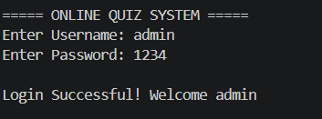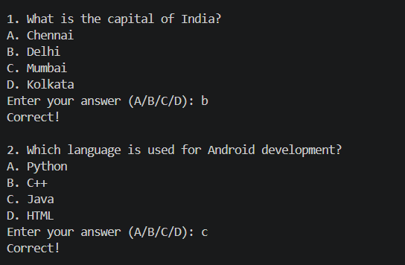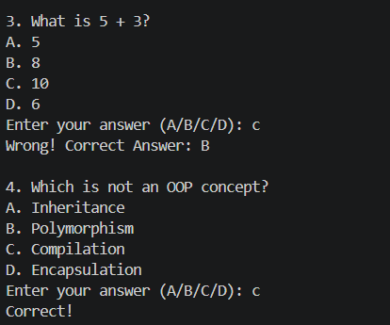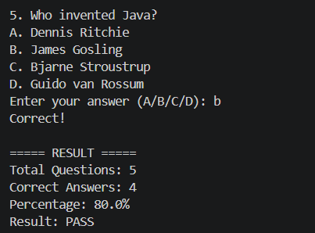

- DISCUSSION & CONCLUSION

7.1 Discussion
The project demonstrates how a simple Java program can automate quiz evaluation. It shows the practical use of programming concepts such as:
- Object-oriented design
- Data handling
- User interaction
Though basic, it forms the foundation for advanced systems like online examination portals.

7.2 Conclusion
The Online Quiz Examination System successfully achieves its objective of automating quiz conduction and evaluation. It reduces manual effort, provides instant results, and ensures accuracy.
The project can be further enhanced by adding:
- GUI interface
- Database support
- Timer functionality

- REFERENCES

The following resources were used during the development of this project:
Books
• Herbert Schildt – Java: The Complete Reference
Websites
• https://www.oracle.com/java
• https://www.geeksforgeeks.org
• https://www.w3schools.com
• https://www.javatpoint.com

